**npm install - g @angular/cli**

**ng version:** version checking and compatibility issue information

**ng help:** angular CLI command help

Note: for nvm related bug , run this command on the folder npm link @angular/cli

* Angular comes with a development server (it is not suitable for productions), it is helpful during development (making request, upload files, PWA features etc). It has live reload features. To run the server **ng serve**

**Project Structure:**

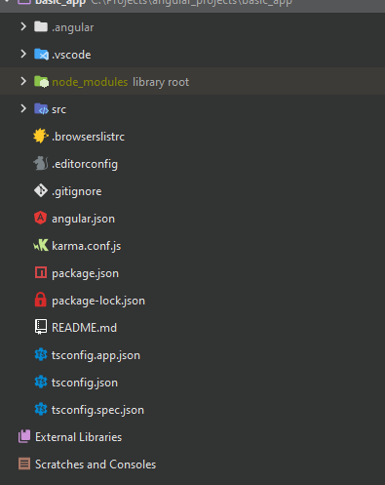

* **.browserslistrc:** we can configure supporting browser version here.
* **.editorconfig:** editor configuration, it helps us resolve formatting issues
* **angular.json:** 
  + **schema** is the path to configuration file for angular,
  + **version** is the version of the configuration file.
  + **newProjectRoot** is the root in case we want to manage several angular project at once.
  + **Projects** contains the list of projects and their own configuration.
    - **Architect** contains the list of commands for building/compiling the project.
  + **defaultproject** name of the default project
* **karma.conf.js:** for tests.
* **tsconfig.app.json:** it runs when we compile our application
* **tsconfig.spec.json:** it runs during test
* **tsconfig.json:** this is the base file that both app and spec extends from.

**Src folder:**

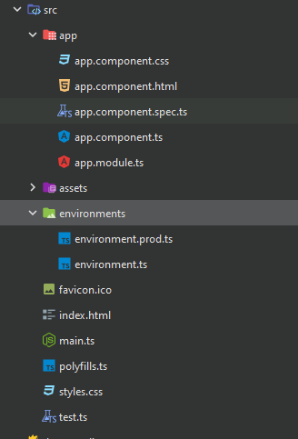

**Main.ts** is the main entry point of the application

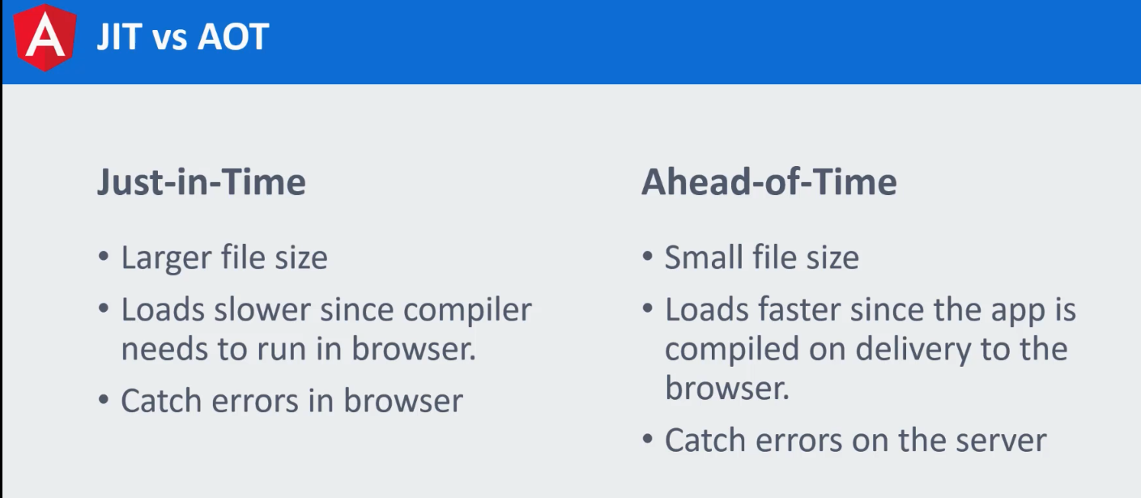

**Loading a platform:**

